Emily Rick
CS580 – Intro to AI
Local Search Analysis Report
November 12, 2026

In this programming assignment, my tasks were to write local search algorithms for two different scenarios. The algorithm was supposed to search through a series of given states in order to find the single, most complete state. Local search starts with an initial state, and is able to make small changes in order to find any better neighboring states, if applicable. It makes these small changes based on the fact if any neighboring states are deemed better than the current state. If it is, then the better neighbor state is made the new current state and the process repeats until the best neighbor state is found. Local search is best used for solving optimization problems, as well as searching through states while using very little memory.
One algorithm that utilizes local search is the Hill Climbing Search algorithm. This assignment had two parts, the Eggholder problem and the N-Queens problem, both of which required the use of the Hill Climbing algorithm. In Hill Climbing, the main goal is to find the local maximum in the state space landscape. It does this by starting at an initial state and continuing to cycle through neighbors in an increasing (or decreasing) fashion. Its final destination would be the state landscapes highest peak (or lowest valley), in which no neighbor has a higher (or lower) value.
For part one of the assignment, the task was to create a Hill Climbing algorithm to find the global minimum of the Eggholder function. The Eggholder function is defined below:
$$f\left(x,y\right)=-(y+47)\sin{\sqrt{\left|\frac{x}{2}+(y+47)\right|}}-x\sin{\sqrt{\left|x-(y+47)\right|}}, -10000<x,y<10000$$
The 3D graph representation of the Eggholder function looks like a standard egg crate, with multiple hills and valleys spread across its surface. The maximum step size for the Eggholder function was set as 1.0; the Hill Climbing algorithm uses this initial position to optimize the function by evaluating all of the closest neighbors and then stepping toward the next lowest value. However, when it does this, it gets stuck at the lowest value since all of the neighboring steps go back uphill.
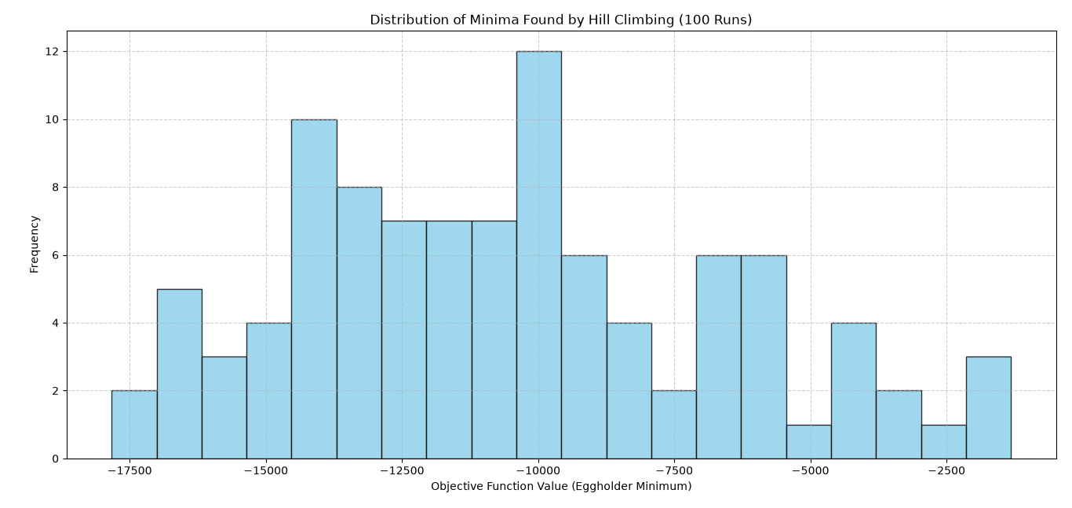
Figure 1: Distribution of Minima Found by Hill Climbing (100 Runs)
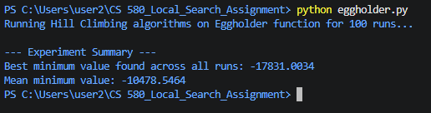
Figure 2: Terminal Output of Hill Climbing Search of the Eggholder Function
For part two of this assignment, the task was to implement another Hill Climbing Search algorithm for the N-Queens problem given a random position. The N-Queens problem is a puzzle that puts N number of queen chess pieces on a board so that no two queens can threaten or attack each other. In order to solve the problem, I wrote a program that repeated the algorithm 300 times total (100 times each for $N=8, N=16,$ and $N=32$, respectively). The program outputted how many times it could find the solution for all three N values, as well as the first ten plots of both the initial and final states. For $N=8$, the program was able to find 12 solutions in 100 runs. For $N=16$ and $N=32$, the program was only able to find 1 solution in 100 runs for each N value.
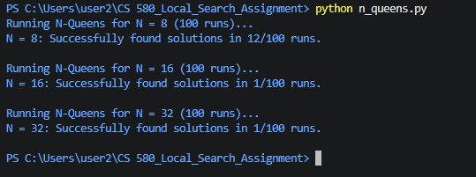
Figure 3: Terminal Output of Hill Climbing Search for the N Queens problem
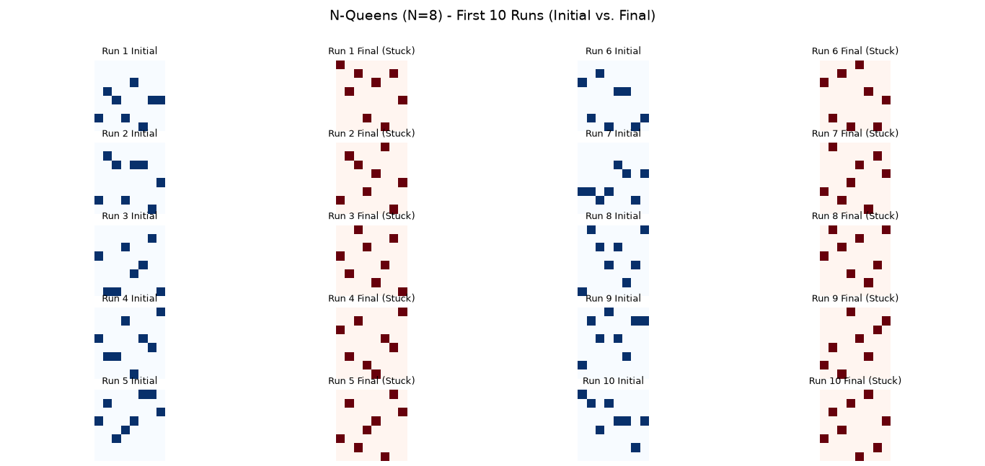
Figure 4: First 10 Runs of Initial vs. Final Plots for $N=8$
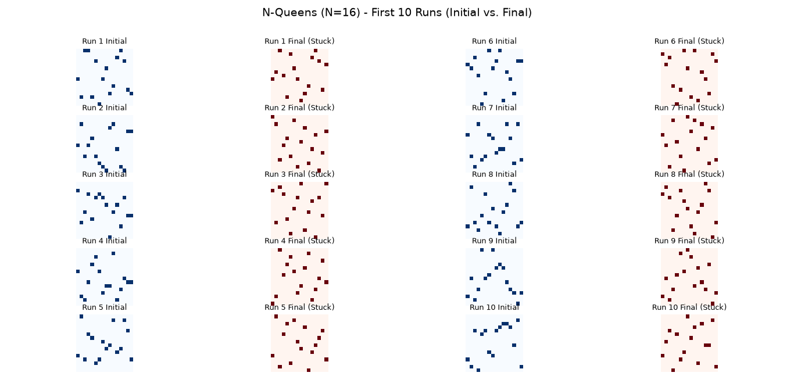
Figure 5: First 10 Runs of Initial vs. Final Plots for $N=16$
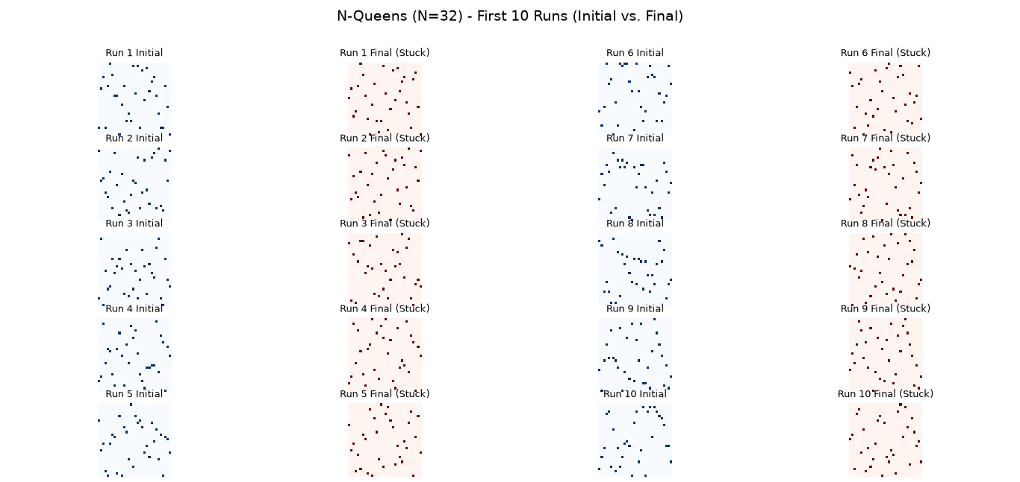
Figure 6: First 10 Runs of Initial vs. Final Plots for $N=32$

